BANK LOAN ANALYSIS USING SQL - REPORT

**A. BANK LOAN REPORT | SUMMARY**

**KPI’s:**

**1. Total Loan Application**

**Sql query**

SELECT COUNT (id) AS total_loan_applicants

FROM bank_loan_data;

**Result/Output**



**2. MTD Loan Applications**

**Sql query**

SELECT COUNT(id) AS MTD_Total_Loan_Applications

FROM bank_loan_data

WHERE MONTH(issue_date) = (

SELECT MAX(MONTH(issue_date))

FROM bank_loan_data

);

**Result/Output**



**3. PMTD Loan Applications**

**Sql query**

SELECT COUNT(id) AS PMTD_Total_Loan_Applications

FROM bank_loan_data

WHERE MONTH(issue_date) = (

SELECT MAX(MONTH(issue_date)) -1

FROM bank_loan_data

);

**Result/Output**



**4. Total Funded Amount**

**Sql query**

SELECT SUM(loan_amount) AS Total_Funded_Amount

FROM bank_loan_data;

**Result/Output**



**5. MTD Total Funded Amount**

**Sql query**

SELECT SUM(loan_amount) AS MTD_Total_Funded_Amount

FROM bank_loan_data

WHERE MONTH(issue_date) = (

SELECT MAX(MONTH(issue_date))

FROM bank_loan_data

);

**Result/Output**



**6. PMTD Total Funded Amount**

**Sql query**

SELECT SUM(loan_amount) AS PMTD_Total_Funded_Amount

FROM bank_loan_data

WHERE MONTH(issue_date) = (

SELECT MAX(MONTH(issue_date)) - 1

FROM bank_loan_data

);

**Result/Output**



**7. Total Amount Received**

**Sql query**

SELECT SUM(total_payment) AS Total_Amount_Received

FROM bank_loan_data;

**Result/Output**



**8. MTD Total Amount Received**

**Sql query**

SELECT SUM(total_payment) AS MTD_Total_Amount_Received

FROM bank_loan_data

WHERE MONTH(issue_date) = (

SELECT MAX(MONTH(issue_date))

FROM bank_loan_data

);

**Result/Output**



**9. PMTD Total Amount Received**

**Sql query**

SELECT SUM(total_payment) AS PMTD_Total_Amount_Received

FROM bank_loan_data

WHERE MONTH(issue_date) = (

SELECT MAX(MONTH(issue_date)) - 1

FROM bank_loan_data

);

**Result/Output**



**10. Average Interest Rate**

**Sql query**

SELECT ROUND(AVG(int_rate) * 100,2) AS Avg_Interest_Rate

FROM bank_loan_data;

**Result/Output**



**11. MTD Average Interest Rate**

**Sql query**

SELECT ROUND(AVG(int_rate) * 100,2) AS MTD_Avg_Interest_Rate

FROM bank_loan_data

WHERE MONTH(issue_date) = (

SELECT MAX(MONTH(issue_date))

FROM bank_loan_data

);

**Result/Output**



**12. PMTD Average Interest Rate**

**Sql query**

SELECT ROUND(AVG(int_rate) * 100,2) AS PMTD_Avg_Interest_Rate

FROM bank_loan_data

WHERE MONTH(issue_date) = (

SELECT MAX(MONTH(issue_date)) - 1

FROM bank_loan_data

);

**Result/Output**



**13. Average Debt to Income Ratio (DTI)**

**Sql query**

SELECT ROUND(AVG(dti) * 100, 2) AS Avg_DTI

FROM bank_loan_data;

**Result/Output**



**14. MTD Debt to Income Ratio (DTI)**

**Sql query**

SELECT ROUND(AVG(dti) * 100, 2) AS MTD_Avg_DTI

FROM bank_loan_data

WHERE MONTH(issue_date) = (

SELECT(MAX(MONTH(issue_date)))

FROM bank_loan_data

);

**Result/Output**



**15. PMTD Debt to Income Ratio (DTI)**

**Sql query**

SELECT ROUND(AVG(dti) * 100, 2) AS PMTD_Avg_DTI

FROM bank_loan_data

WHERE MONTH(issue_date) = (

SELECT(MAX(MONTH(issue_date))) - 1

FROM bank_loan_data

);

**Result/Output**



**16. Total Good Loan Application**

**Sql query**

SELECT COUNT(id) AS Total_Good_Loan_Applications

FROM bank_loan_data

WHERE loan_status IN('Fully Paid', 'Current');

**Result/Output**



**17. Percentage of Good Loan**

**Sql query**

SELECT

ROUND(

(COUNT(CASE WHEN loan_status IN ('Fully Paid', 'Current') THEN id END) * 100 / COUNT(id)),

2

) AS Good_loan_applications_percentage

FROM bank_loan_data;

**Result/Output**



**18. Total Good Loan Funded Amount**

**Sql query**

SELECT SUM(loan_amount) AS Good_Loan_Funded_Amount

FROM bank_loan_data

WHERE loan_status IN('Fully Paid', 'Current');

**Result/Output**



**19. Total Bad Loan Applications**

**Sql query**

SELECT COUNT(id) AS Total_Bad_Loan_Applications

FROM bank_loan_data

WHERE loan_status = 'Charged Off';

**Result/Output**



**20. Percentage of Bad Loan Applications**

**Sql query**

SELECT

ROUND(

(COUNT(CASE WHEN loan_status = 'Charged Off' THEN id END) * 100 / COUNT(id)),

2

) AS Bad_loan_percentage

FROM bank_loan_data;

**Result/Output**



**21. Total Bad Loan Funded Amount**

**Sql query**

SELECT SUM(loan_amount) AS Bad_Loan_Funded_Amount

FROM bank_loan_data

WHERE loan_status = 'Charged Off';

**Result/Output**



**22. Summary by loan status**

**Sql query**

SELECT loan_status,

COUNT(id) AS Total_Loan_Applications,

SUM(total_payment) AS Total_Amount_Received,

SUM(loan_amount) AS Total_Funded_Amount,

AVG(int_rate *100) AS Interest_Rate,

AVG(dti * 100) AS DTI

FROM bank_loan_data

GROUP BY loan_status;

**Result/Output**

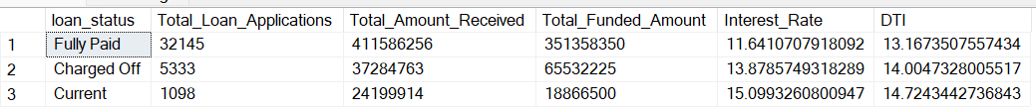

**22. MTD Total Amount Funded, Total Amount Received by Loan Status**

**Sql query**

SELECT loan_status,

SUM(loan_amount) AS MTD_Total_Funded_Amount,

SUM(total_payment) AS MTD_Total_Amount_Received

FROM bank_loan_data

WHERE MONTH(issue_date) = (

SELECT MAX(MONTH(issue_date))

FROM bank_loan_data

)

GROUP BY loan_status;

**Result/Output**

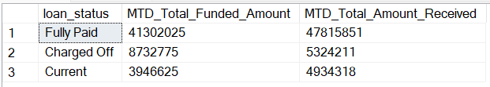

**22. PMTD Total Amount Funded, Total Amount Received by Loan Status**

**Sql query**

SELECT loan_status,

SUM(loan_amount) AS PMTD_Total_Funded_Amount,

SUM(total_payment) AS PMTD_Total_Amount_Received

FROM bank_loan_data

WHERE MONTH(issue_date) = (

SELECT MAX(MONTH(issue_date))

FROM bank_loan_data

) - 1

GROUP BY loan_status;

**Result/Output**

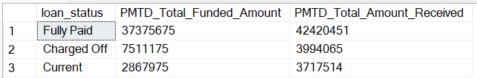

**B. BANK LOAN REPORT | OVERVIEW**

**1. Monthly Trend by Issue Date**

**Sql query**

SELECT DATENAME(MONTH, issue_date) AS Month_Name,

MONTH(issue_date) AS Month_No,

COUNT(id) AS Total_Loan_Applications,

SUM(loan_amount) AS Total_Funded_Amount,

SUM(total_payment) AS Total_Amount_Received

FROM bank_loan_data

GROUP BY DATENAME(MONTH, issue_date),MONTH(issue_date)

ORDER BY Month_No;

**Result/Output**

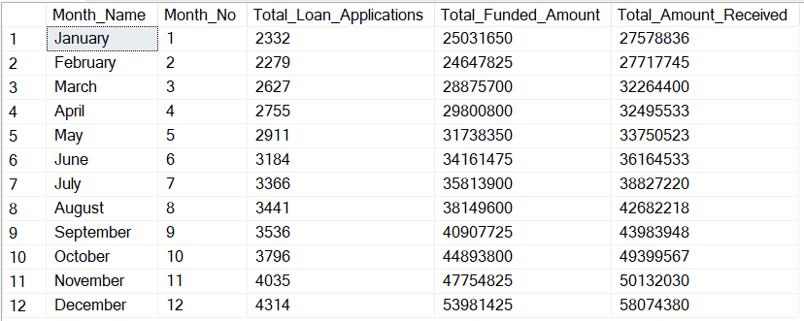

**2. Regional Analysis by State**

**Sql query**

SELECT address_state AS Region,

COUNT(id) AS Total_Loan_Applications,

SUM(loan_amount) AS Total_Funded_Amount,

SUM(total_payment) AS Total_Amount_Received

FROM bank_loan_data

GROUP BY address_state

ORDER BY COUNT(id) DESC;

**Result/Output**

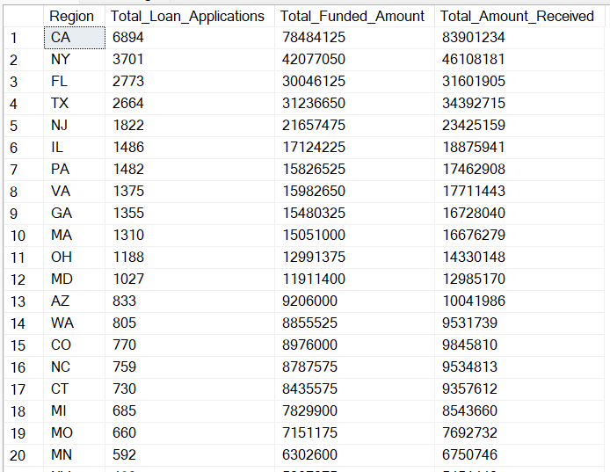

**3. Loan Term Analysis**

**Sql query**

SELECT term AS Loan_Term,

COUNT(id) AS Total_Loan_Applications,

SUM(loan_amount) AS Total_Funded_Amount,

SUM(total_payment) AS Total_Amount_Received

FROM bank_loan_data

GROUP BY term

ORDER BY term;

**Result/Output**

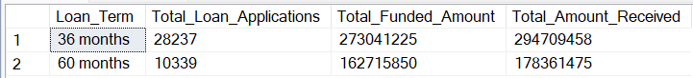

**4. Employee Length Analysis**

**Sql query**

SELECT emp_length,

COUNT(id) AS Total_Loan_Applications,

SUM(loan_amount) AS Total_Funded_Amount,

SUM(total_payment) AS Total_Amount_Received

FROM bank_loan_data

GROUP BY emp_length

ORDER BY emp_length;

**Result/Output**

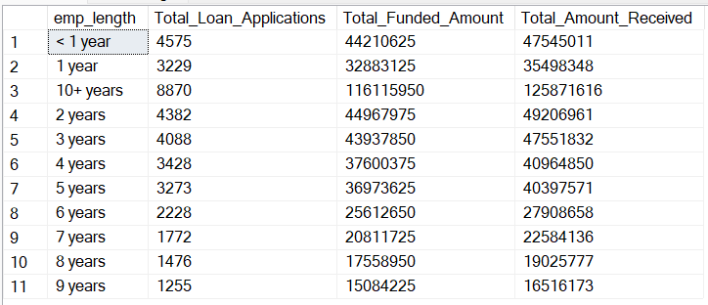

**5. Loan Purpose Breakdown**

**Sql query**

SELECT purpose AS Loan_Purpose,

COUNT(id) AS Total_Loan_Applications,

SUM(loan_amount) AS Total_Funded_Amount,

SUM(total_payment) AS Total_Amount_Received

FROM bank_loan_data

GROUP BY purpose

ORDER BY COUNT(id) DESC;

**Result/Output**

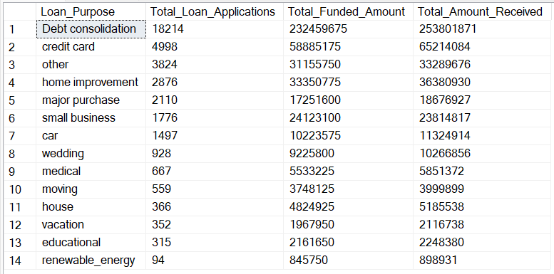

**6. Home Ownership Analysis**

**Sql query**

SELECT home_ownership,

COUNT(id) AS Total_Loan_Applications,

SUM(loan_amount) AS Total_Funded_Amount,

SUM(total_payment) AS Total_Amount_Received

FROM bank_loan_data

GROUP BY home_ownership

ORDER BY COUNT(id) DESC;

**Result/Output**

